**June 26, 2019**

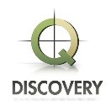

Starboard Capital Partners, LLC (“Starboard”) is pleased to announce the sale of QDiscovery LLC to Xact Data Discovery on June 26, 2019.

QDiscovery provides eDiscovery, forensics, managed review and consulting services to major law firms and corporations.

Starboard co-sponsored this transaction with Bridge Investments, LLC and together we significantly expanded and enhanced the Company’s capabilities over the four-year investment term. The exit produced an exceptional return for Starboard and Bridge Investments.